MST implementation using Kruskal's and Prim's Algorithm
Kruskal’s Algorithm
#include <stdio.h>
#include <stdlib.h>

#define MAX 100

typedef struct {
int u, v, weight;
} Edge;

int parent[MAX];

int find(int i) {
while (parent[i])
i = parent[i];
return i;
}

int uni(int i, int j) {
if (i != j) {
parent[j] = i;
return 1;
}
return 0;
}

int compare(const void* a, const void* b) {
Edge* e1 = (Edge*)a;
Edge* e2 = (Edge*)b;
return e1->weight - e2->weight;
}

void kruskal(Edge edges[], int n, int e) {
Edge mst[MAX];
int i = 0, j = 0, total = 0;

qsort(edges, e, sizeof(edges[0]), compare);

while (j < n - 1 && i < e) {
int u = find(edges[i].u);
int v = find(edges[i].v);
if (uni(u, v)) {
mst[j++] = edges[i];
total += edges[i].weight;
}
i++;
}

printf("\nKruskal's MST:\n");
for (i = 0; i < j; i++)
printf("%d - %d: %d\n", mst[i].u, mst[i].v, mst[i].weight);
printf("Total cost: %d\n", total);
}

int main() {
int n, e;
printf("Enter number of vertices and edges: ");
scanf("%d %d", &n, &e);

Edge edges[MAX];
printf("Enter edges (u v weight):\n");
for (int i = 0; i < e; i++)
scanf("%d %d %d", &edges[i].u, &edges[i].v, &edges[i].weight);

kruskal(edges, n, e);

return 0;
}
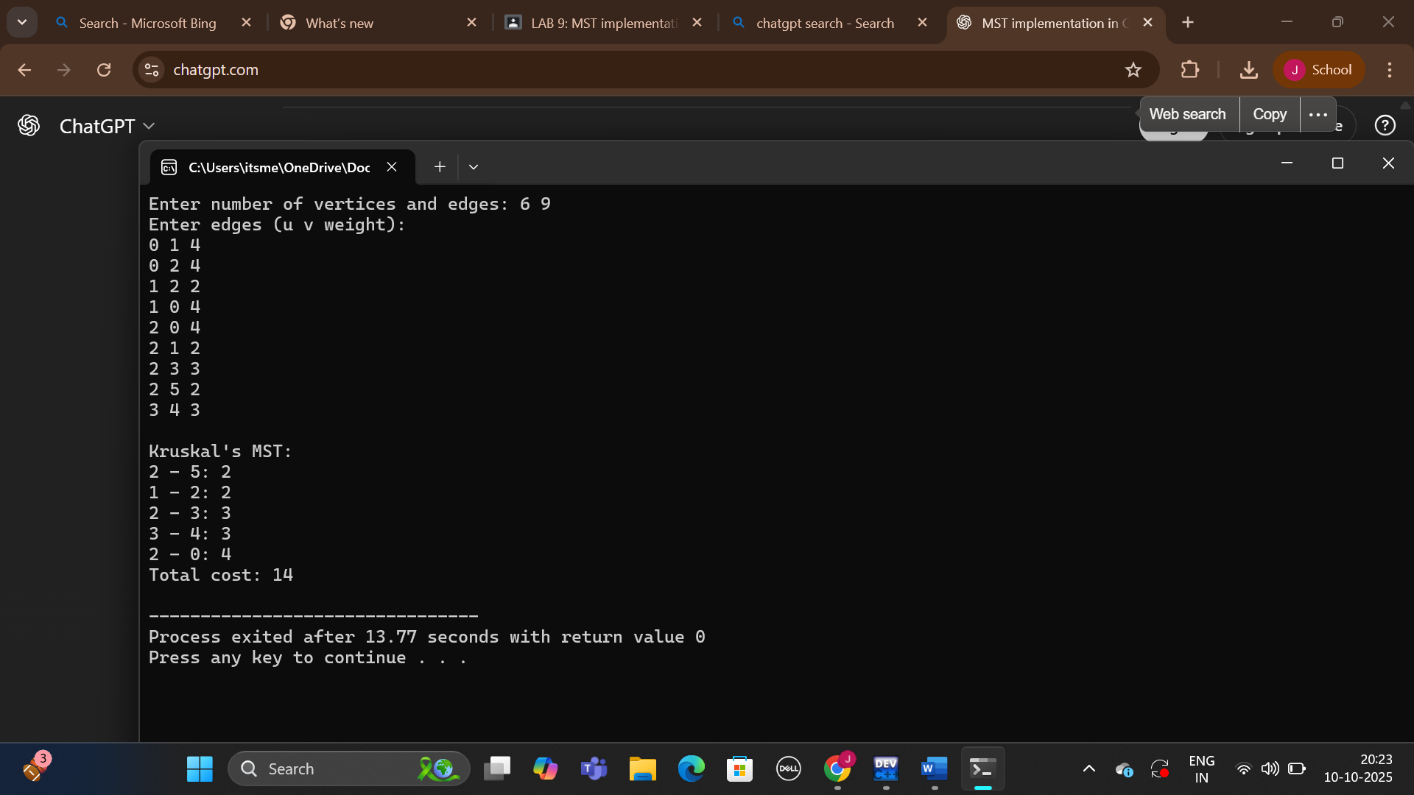

Prim’s Algorithm

#include <stdio.h>
#include <limits.h>

#define MAX 100
#define INF 9999

void prim(int graph[MAX][MAX], int n) {
int selected[MAX] = {0};
int no_edge = 0;
selected[0] = 1;
int x, y;
int total = 0;

printf("\nPrim's MST:\n");
while (no_edge < n - 1) {
int min = INF;
x = y = 0;

for (int i = 0; i < n; i++) {
if (selected[i]) {
for (int j = 0; j < n; j++) {
if (!selected[j] && graph[i][j]) {
if (min > graph[i][j]) {
min = graph[i][j];
x = i;
y = j;
}
}
}
}
}
printf("%d - %d: %d\n", x, y, graph[x][y]);
total += graph[x][y];
selected[y] = 1;
no_edge++;
}

printf("Total cost: %d\n", total);
}

int main() {
int n;
int graph[MAX][MAX];

printf("Enter number of vertices: ");
scanf("%d", &n);

printf("Enter adjacency matrix (0 for no edge):\n");
for (int i = 0; i < n; i++)
for (int j = 0; j < n; j++)
scanf("%d", &graph[i][j]);

prim(graph, n);

return 0;
}
